
Requirement & Design Specification
Classroom Facilities Management System (CFMS)
Version: 1.0
– Hanoi,January 2026 –
OEMS-SRS_v1.0 Page 1 / 20
Record of Changes
Version | Date | A*  M, D | In charge | Change Description
V1.0 | 7/1 | A | GiapND | Add System Context and External Entities
V1.0 | 9/1 | M | KhangND | Modified System Context (Redesign Context Diagram)
V1.0 | 9/1 | A | TungPV | Add Business Process
V1.0 | 10/1 | A
V1.0 | 11/1 | A

*A - Added M - Modified D - Deleted

OEMS-SRS_v1.0 Page 2 / 20
Contents
Record of Changes........................................................................................................................................ 2
I. Overview....................................................................................................................................................5
1. System Context..................................................................................................................................... 5
2. External Entities....................................................................................................................................5
3. Business Processes............................................................................................................................... 5
3.1 Sale Process.................................................................................................................................... 6
3.2 Customer Support...........................................................................................................................6
4. User Requirements............................................................................................................................... 6
4.1 UCs for Guest.................................................................................................................................. 7
4.2 UCs for Student...............................................................................................................................7
4.3 …....................................................................................................................................................
5. System Functionalities.......................................................................................................................... 7
5.1 Screens Flow................................................................................................................................... 7
5.2 Screen Authorization...................................................................................................................... 8
5.3 Non-UI Functions............................................................................................................................ 8
II. Functional Requirements..........................................................................................................................9
1. Feature Name1..................................................................................................................................... 9
1.1 SubFeature Name1.1...................................................................................................................... 9
1.2 SubFeature Name1.2...................................................................................................................... 9
2. User Authentication..............................................................................................................................9
2.1 User Register...................................................................................................................................9
3. System Administration..........................................................................................................................9
3.1 Master Data.................................................................................................................................... 9
3.2 User Management........................................................................................................................ 10
III. System Design........................................................................................................................................11
1. Software Architecture.........................................................................................................................11
1.1 Overall Architectural Diagram................................................................................................... 11
1.2 Component Descriptions.............................................................................................................. 11
2. Code Package Design.......................................................................................................................... 11
2.1. Package Diagram..........................................................................................................................12
2.2 Package Descriptions.................................................................................................................... 12
3. Database Design................................................................................................................................. 12
3.1 Database Schema..........................................................................................................................13
3.2 Table Descriptions.........................................................................................................................13

GAMS-SRS_v1.0 Page 3 / 20

I. Overview
1. System Context
[Gives the overall description about the product with some introduction and the context diagram. The context diagram presents the boundary and connections between the system you’re developing and everything else in the universe. This identifies external entities (or terminators – software, hardware, human components, and other systems) outside the system that interface to it in some way, as well as data, control, and material flows between the terminators and the system.]
The Classroom Facilities Management System (CFMS) is a web-based platform designed for public high schools. It streamlines the lifecycle of assets—from the initial request to the Ministry of Education, through intake, allocation, maintenance, and final return or liquidation. It replaces manual, paper-based tracking with a digital ledger to ensure accountability and efficiency.
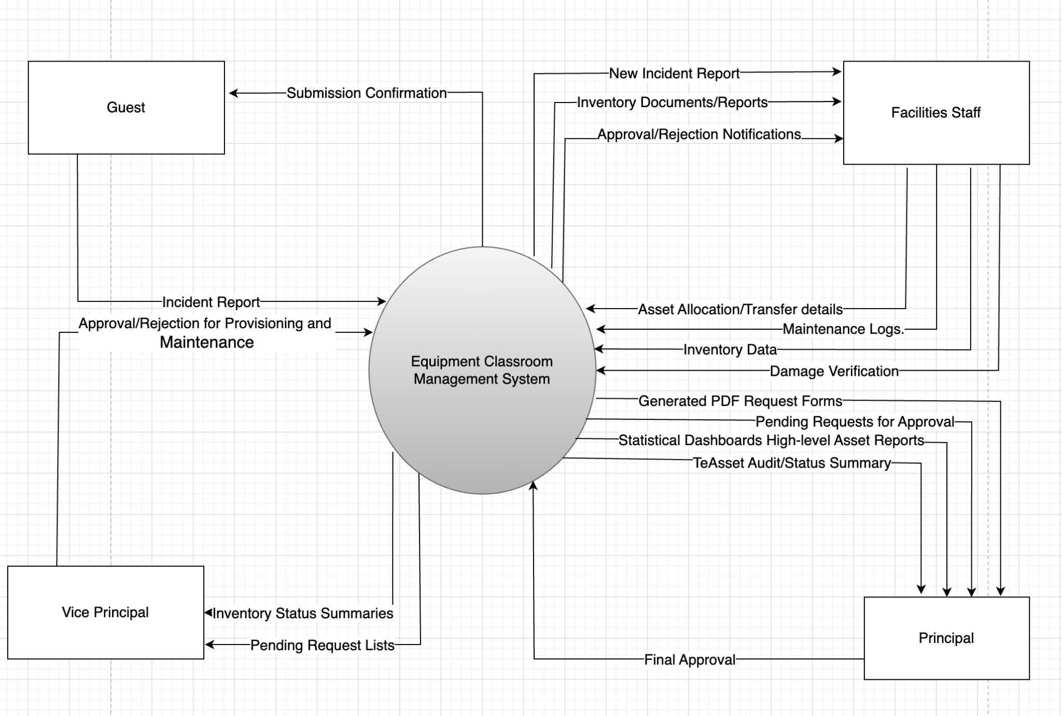
>>
2. External Entities
[Describe the external entities who/what might interact with your system as mentioned in the context diagram above, using the form of table as following]
# | Entity | Description
1 | Guest | Anonymous users (Students/Visitors) who report damaged property via QR codes.
2 | Facilities Staff | Operational users who manage inventory, verify reports, and handle physical facilities movements
3 | Vice Principal | Secondary approver and internal overseer of facility status and maintenance requests
4 | Principal | High-level approver for provisioning requests and consumer of executive reports.

3. Business Processes
[Provide business processes () using the swim-lane diagram(s) like sample below A business process a collection of activities that takes one or more kinds of input and creates an output that is of value to the customer. The customer for a business process may be a traditional external
customer (the person who buys the finished product), or it may be an internal customer (such as a colleague in another department)]

The system follows the "Provisioning & Handover" model / Hệ thống tuân theo mô hình "Cung ứng & Bàn giao":

- Provisioning Flow (Quy trình Cung ứng): Staff summarizes needs -> Vice Principal reviews -> Principal approves -> Export PDF to Ministry. (Nhân viên tổng hợp nhu cầu -> Phó Hiệu trưởng soát xét -> Hiệu trưởng phê duyệt -> Xuất PDF gửi Bộ).
- Intake Flow (Quy trình Tiếp nhận): Ministry delivers items -> Staff performs physical verify -> Input data into System. (Bộ bàn giao tài sản -> Nhân viên kiểm kê thực tế -> Nhập dữ liệu vào hệ thống).
- Maintenance Flow (Quy trình Bảo trì): Guest/Staff reports damage -> Staff verifies -> Vice Principal approves repair -> Staff records result. (Khách/NV báo hỏng -> NV xác minh -> Phó Hiệu trưởng duyệt sửa chữa -> NV cập nhật kết quả).
- Liquidation/Return Flow (Quy trình Thanh lý/Thu hồi): Staff identifies unrepairable/obsolete assets -> Principal approves -> Generate return document -> Physical return to Ministry -> Update inventory status. (Nhân viên xác định tài sản hỏng không thể sửa chữa/hết hạn -> Hiệu trưởng phê duyệt -> Tạo biên bản bàn giao -> Hoàn trả thực tế về Bộ -> Cập nhật trạng thái trên hệ thống).
3.1 Sale Process
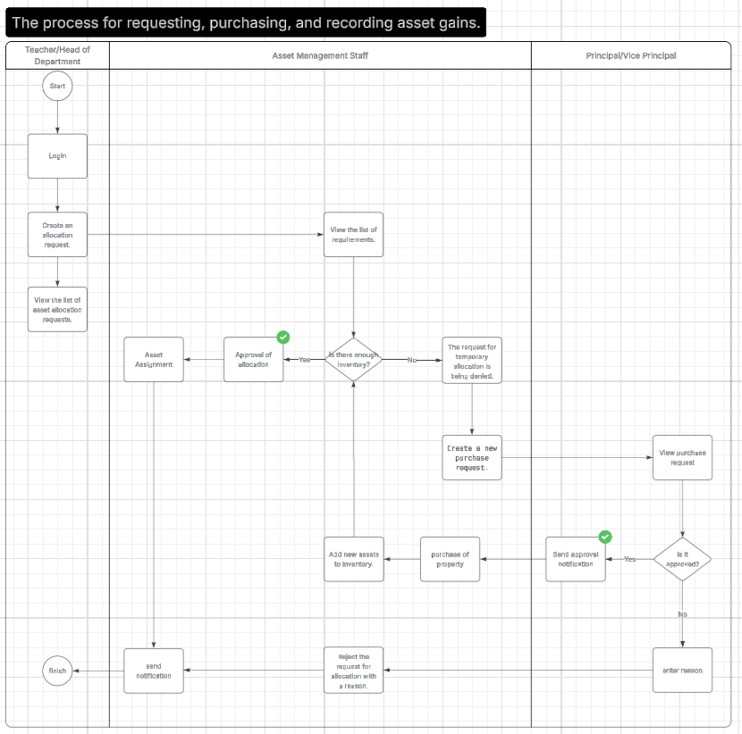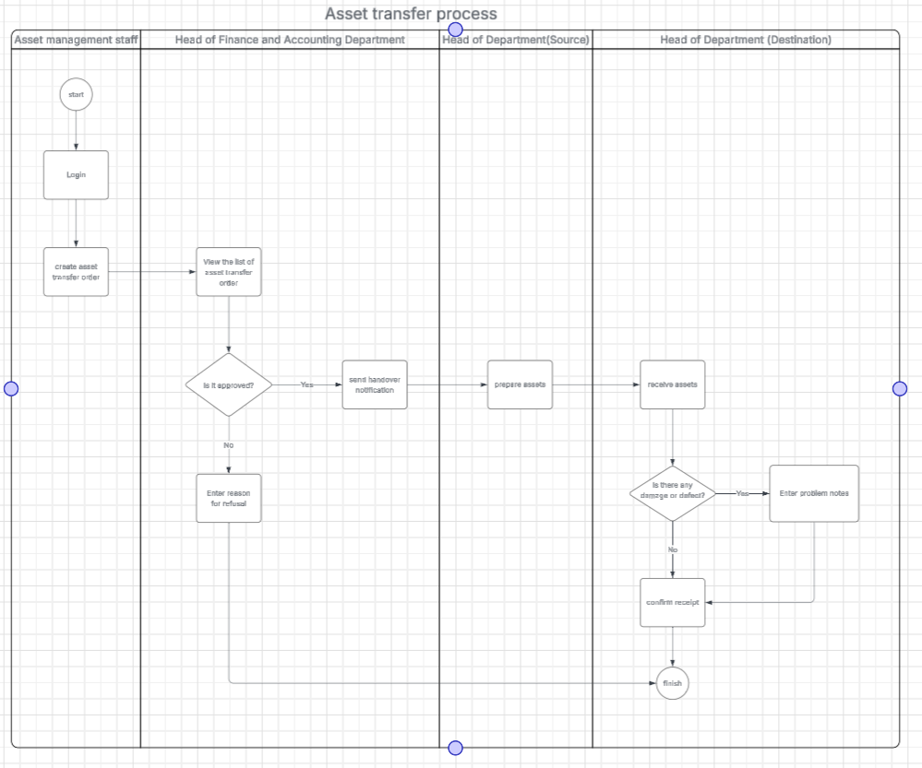

Process Description
Step  # | Step Name | Detailed Description | Role
1. | báo cáo sự cố | Ai cũng có thể quét mã QR trên thiết bị bị hỏng, điền thông tin sự cố và gửi báo cáo. | bất kì
2. | Nhân viên kho nhận thông báo | Hệ thống tự động gửi thông báo cho Nhân viên kho khi có báo cáo sự cố. | Nhân viên kho
3. | Kiểm tra hiện trạng | Nhân viên kho đến kiểm tra trực tiếp thiết bị, xác định mức độ hỏng hóc. | Nhân viên kho
4. | Trung chuyển nếu có đồ dự phòng | Nếu hỏng nặng và còn đồ dự phòng, nhân viên kho lấy đồ thay thế, giao cho giáo viên và cập nhật CSDL. | Nhân viên kho
5. | Gửi Form xin cấp nếu hết đồ | Nếu không còn đồ dự phòng, nhân viên kho điền Form xin cấp thiết bị mới và gửi cho Phó Hiệu trưởng | Nhân viên kho
6 | Phó Hiệu trưởng duyệt Form | Phó Hiệu trưởng xem xét Form, nếu đồng ý thì in đơn và gửi đề xuất mua sắm/cấp mới. | Phó Hiệu trưởng
7

3.2 Customer Support
…
4. User Requirements
In this section, you need to p
ID | Use Case | Feature | Main Actor | Use Case Description

GAMS-SRS_v1.0 Page 6 / 20
01 | Report Damage | Maintenance | All user | Report asset issues via QR code (anonymous, photo attachment) or link.
02 | View inventory | Asset Management | Facilities Staff | Browse, filter, and search the school's asset registry.
03 | Allocate Asset | Asset Allocation | Facilities Staff | Assign assets to specific rooms, departments, or personnel.
04 | Add Inventory | Inventory | Facilities Staff | Record new assets received from Ministry documentation.
05 | Create Provisioning | Provisioning | Facilities Staff | Compile asset needs and generate formal request documents.
06 | Review Request | Approval Workflow | Vice Principal | Review, revise, or provide initial approval for requests.
07 | Final Approval | Management | Vice Principal | Final validation and formal sign-off on asset requests.
08 | Request Form Generation | Document Management and Exporting | Principal | Generate pdf request form from system to hand over third party.
09 | View Dashboard | Reports & Stats | Principal | Access visual analytics and summary reports of school assets.

4.1 UCs for Guest
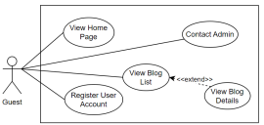
4.2 UCs for Student
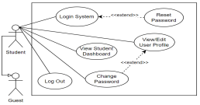
4.3 …
5. System Functionalities
[Provide functionality overview of software system: screen flow, screen descriptions, system user roles, screen authorization, non-screen functions, ERD]
5.1 Screens Flow
[This part shows the system screens and the relationship among screens. You can draw the Screens Flow for the system in the form of diagram as below.]
GAMS-SRS_v1.0 Page 7 / 20
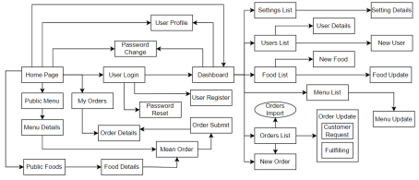5.2 Screen Authorization
[Provide the system roles authorization to the system features (down to screens, and event to the screen activities if applicable) in the table form as below – replace Role-Name1, Role-Name2,… with your specific system user role names]
Screen | Role-Name1 | Role-Name2 | Role-Name3 | …
<<Screen Name1>> | X |  | X | X
<<Screen Activity>> |  |  | X | X
<<Screen Name2>> | X |  | X
Query All Data | X
Query Own Data |  |  | X
Add New Data |  |  | X | X
Update All Data |  |  |  | X
Update Own Data |  |  |  | X
Delete Data
…

5.3 Non-UI Functions
[Provide the descriptions for the non-screen system functions, i.e batch/cron job, service, API, etc.]
# | Feature | System Function | Description
1 | <<Feature Name>> | <<Function Name1>> | <<Function Name1 Description>>
2 | …

GAMS-SRS_v1.0 Page 8 / 20
II. Functional Requirements
[Provide descriptions about the system’s functions/screens. The functions/screens are grouped by the system features, and even sub-features if needed. For the screens, you need to provide the screen layouts (mock-up screens) and relevant specifications if needed]
1. Feature Name1
1.1 SubFeature Name1.1
1.1.1 Screen/Function Name1
[Content #1: UI layout (Mockup screen prototype)]
[Content #2: brief descriptions of the screen/function, mapped to the relevant use cases] [Content #3: provide further descriptions for the screen’s components/fields using table format below]
Field Name | Description
Field Name1 | Field description: data type min/max length or value, initial data, etc.
Field Name2 | …
Field Group-Name1
Field Name3 | …
Field Name4 | …
Field Group-Name2
… | …

1.1.2 Screen/Function Name2
…
1.2 SubFeature Name1.2
…
2. User Authentication
2.1 User Register
…
3. System Administration
3.1 Master Data
3.1.1 Setting List
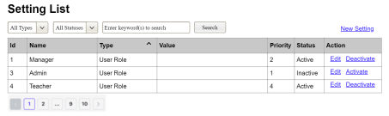
This screen allows the Administrator to:
● View Setting List: view list of current master data.
GAMS-SRS_v1.0 Page 9 / 20
● Filter Setting List: filter master data by data types, statuses
● Search Settings: enter keyword(s) to search master data by their names or values ● Sort Setting List: sort mater data list (ascending, descending) by clicking column headers On the screen, s/he can also
● Activate/Deactivate Setting: change status of a specific inactive/active master data ● Choose to go to the Setting Details screens for adding new or updating an existing master data by clicking the New Setting or Edit link.
Field Description
Field Name | Description
(1) | Initial values: all the active setting names with null or blank type  Hover the mouse to show the field name: “Setting Type”
(2) | Initial values: All Statuses, Active, Inactive (default value “All Status”) Hover the mouse to show the field name: “Setting Status”
(3) | The change-status action is Activate or Deactivate depending on the current status of the relevant setting (Inactive or Active, respectively).

3.1.2 Setting Details
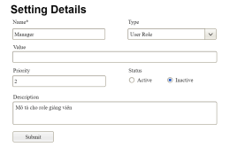
This screen allows the Administrator to:
● Add New Setting: add new master data.
● Update Setting Details: update details of a specific master data
Field Description
Field Name | Description
Name | Data type: non-digit string, max length of 20 characters
Type | Initial data values: all active setting names (with null or blank type)
Value | Data type: any string, max length of 100 characters
Priority | Data type: a positive integer
Description | Data type: any string, max length of 200 characters

3.2 User Management
3.2.1 User List
…
GAMS-SRS_v1.0 Page 10 / 20
III. System Design
1. Software Architecture
[The content of this section includes the overall architectural diagram which includes the sub-systems and/or components, the external systems (if any), and the relationships (communication messages) among them. You need also provide the explanation for each of the diagram components (modules, sub-systems, external systems, etc.)].
1.1 Overall Architecturural Diagram
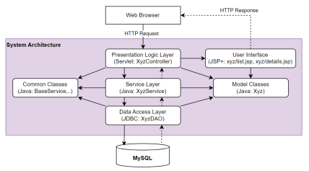1.2 Component Descriptions
No | Component | Description
01 | Presentation Logic Layer | <Description of the component>
02 | User Interface | <Description of the package>
03 | …

-
2. Code Package Design
[Provide the package diagram for each sub-system. The content of this section including the overall package diagram, the explanation, package and class naming conventions in each package. Please see the sample & description table format below]
GAMS-SRS_v1.0 Page 11 / 20
2.1 Package Diagram
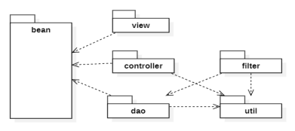2.2 Package Descriptions
No | Package | Description
01 | View | <Description of the package>
02 | bean | <Description of the package>
03 | …

3. Database Design
[Provide the files description, database table relationship & table descriptions like example below] 3.1 Database Schema
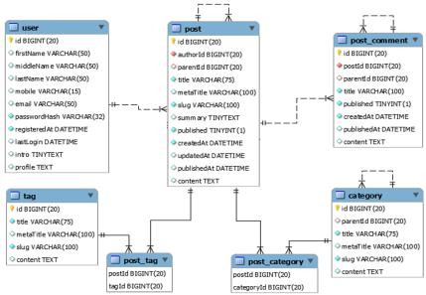GAMS-SRS_v1.0 Page 12 / 20
3.2 Table Descriptions
3.2.1 table_name1
[Provide brief description of the table here]
[Provide the detailed table fields description using below table format
* PK~Primary Key; FK~Foreign Key; UN~Unique; NN ~ not null
No | Field | PK | FK | UN | NN | Description
01 | <field_name1> |  |  |  |  | <Description of the field_name1>
02 | <field_name2> |  |  |  |  | …
..

3.2.2 table_name2
…
GAMS-SRS_v1.0 Page 13 / 20

